Mentor Handbook

“Educate, Equip, and Empower our Students to Become Lifelong Learners.”

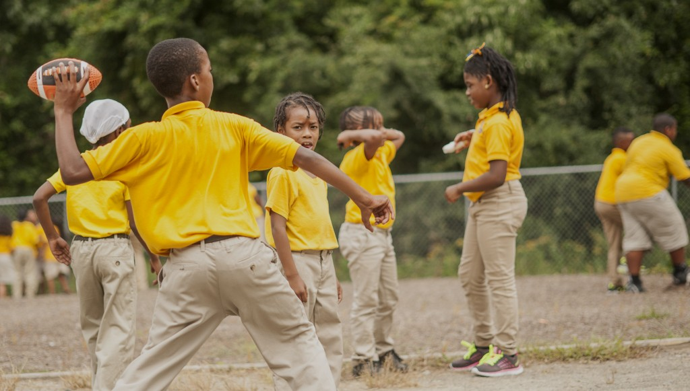

Designed in August 2017
Mentor Program

The goal of the teaching profession is to educate our students. Teachers have always been collaborative and collegial, even when it meant taking a new teacher by the arm and walking him through a problem. That sort of informal exchange will always be part of our professional culture. But we also must recognize the importance of a formal process of professional induction to ensure that students at Carter Community Charter School have a quality teacher in every classroom. Professional development is crucial to retaining good teachers.

Essential Elements
- A mentor program should be individualized and aligned with district goals and needs.

- The beginning teacher is not overextended or diverted with out-of-field teaching assignments and/or extracurricular duties. New teachers, in particular, need time for reflection, self-evaluation, and affirmation.

- Second year of the mentoring program is monitored. A second-year teacher often starts the year knowing what does and does not work, with understanding why. The emphasis of second-year monitoring is to solidify the foundation established the first year by making adjustments based on experience.

- Universities and colleges are called on for support. Higher education can provide resources for professional growth and help bridge the gap between undergraduate knowledge and practical experience.

- Collaboration (formal or informal) time is provided. Time to reflect is the first step after which a teacher hones and affirms skills by verbalizing beliefs and strategies.

- The mentoring program will be monitored by the Administration and the Lead Teachers team to ensure success.

GUIDELINES FOR MENTOR SELECTION

CCCS will consider several factors when selecting its mentors. Experienced teachers that have demonstrated success in the classroom, who are open to continued training, and who have a positive attitude toward mentoring should be recruited as mentor teachers.

Ideally, a mentor would be a faculty member with certification and experience in the same area as the beginning teacher or one who teaches at the same grade level as the beginning teacher. An administrator certificated at the same level as the beginning teacher could also serve as a mentor.

The building principal is responsible for identifying mentor teachers and asking them to serve. This task should be accomplished in a timely fashion to allow adequate time for mentors to help beginning teachers prepare their initial professional development plan.

In certain cases, it may be advisable to reassign mentor teachers. For example, if a new teacher wants to work in a second area of certification, a new mentor could be assigned. Major personality differences or disagreements between a new teacher and mentor warrant reassignment. In such cases, the principal, must work to protect the dignity of those involved.

Mentor Training

Why is it that a teacher can be comfortable teaching students but not peers? The key is having the necessary skills, defining the role and knowing the expectations. The mentor training framework areas are the key to successful implementation and practice. Evaluation and support are essential for high-quality, ongoing staff development training.

Thorough and consistent development of mentor teachers is important to the success of the program. CCCS, in partnership with the Durham Charter School cohort and seeking opportunities from the NC Department of Instruction, administration and mentor will arrange activities and trainings for mentor(s) to attend.

The North Carolina Department of Instruction call for mentor training programs to address the following topics:

- The roles and responsibilities of the new teacher’s professional development team: the new teacher, the mentor teacher, the supervisor (typically the building principal), and if applicable, the higher education representative
- Coaching and counseling techniques
- The format and content of the professional development plan
- Teacher evaluation, content, and process
- Problem-solving strategies
- Listening and inquiry skills
- Resources available to beginning teachers at the district, higher education, regional, and state levels
- Peer coaching
- Current theories and models of instruction and classroom management

Mentor Rules and Responsibilities

Imagine this scenario: Feeling isolated, a new teacher risks sharing his fears with a mentor. Later, the new teacher overhears his problem being discussed by colleagues. He loses faith in his peers, and his isolation and fear increase.

The culture of the education profession is largely determined by mentors. State law specifically builds professional confidentiality into the mentor program, an acknowledgement that making mistakes is part of the learning experience.

Giving time to students is a constant throughout a teacher’s day. Mentors also must be willing to give time to new teachers. Taking time to listen and understand a new teacher’s experiences and problems builds professional respect and leads to the sort of dialogue needed for professional growth. Establish open lines of communication.

The mentor role and responsibilities include:

- Helping new teacher prepare for the start of school by providing curriculum guides, previous teacher’s files, materials, and human resources
- Regular initiation of contact with the new teacher to discuss specific topics that have been discussed
- Available to listen and answer questions
- Develop strong professional relationship with new teacher, based on mutual respect and trust
- Maintains confidentiality at all times and reinforces trust
- Assists in developing, reviewing, and revising professional development plan, encouraging growth and career advancement
- Continually discusses policies, rules, and cultural norms

Calendar for Mentor/Beginning Teacher Activities

- The mentor can amend the months for the activities as long as they are covered throughout the year.

August—Monthly Meeting

___ 1. Attend the building principal’s meeting for new teachers
___ 2. Introduce new teacher to faculty and staff
___ 3. Review building policies, procedures, handbook, and discipline policies
___ 4. Identify professional organizations
___ 5. Look over a lesson plan
___ 6. Discuss staff development through PDC and procedure for filing forms
___ 7. Discuss preparation for a substitute
___ 8. Discuss parent/teacher communication
___ 9. Discuss supervision of students
___ 10. Discuss obtaining supplies and materials
___ 11. Discuss school policies regarding holiday events and activities
___ 12. Provide instruction for any office copiers, etc.
___ 13. PTA
___ 14. Parent/Teacher Open House
___ 15. Questions/Concerns

September—Monthly Meeting

___ 1. Begin work on Professional Development plan
___ 2. Discuss extra-curricular activities and supervision policies
___ 3. Discuss grading policies, deficiency notices, and quarterly grades
___ 4. Discuss procedures for school closings for bad weather
___ 5. Review safety drills
___ 6. Student make-up work policies
___ 7. Review student handbook
___ 8. Questions/Concerns

October—Monthly Meeting

___ 1. End of first quarter grading period procedures
___ 2. Parent-Teacher Conferences
___ 3. Maintaining Discipline
___ 4. Mentor/New Teacher Observations
___ 5. Classroom Management
___ 6. Continued work on PDP, give copy to building principal
___ 7. Questions concerning PBTE
___ 8. Questions/Concerns

September—Monthly Meeting

___ 1. Begin work on Professional Development plan
___ 2. Discuss extra-curricular activities and supervision policies
___ 3. Discuss grading policies, deficiency notices, and quarterly grades
___ 4. Discuss procedures for school closings for bad weather
___ 5. Review safety drills
___ 6. Student make-up work policies
___ 7. Review student handbook
___ 8. Questions/Concerns

October—Monthly Meeting

___ 1. End of first quarter grading period procedures
___ 2. Parent-Teacher Conferences
___ 3. Maintaining Discipline
___ 4. Mentor/New Teacher Observations
___ 5. Classroom Management
___ 6. Continued work on PDP, give copy to building principal
___ 7. Questions concerning PBTE
___ 8. Questions/Concerns

November—Monthly Meeting

___ 1. Keeping record and artifacts in file for fulfilling required PD hours for certification
___ 2. Professional development opportunities and procedures
___ 3. Curriculum/lesson plan review
___ 4. Building events/activities
___ 5. Observe a teacher other than mentor
___ 6. Mid-term grade reports
___ 7. Questions/Concerns

December—Monthly Meeting

___ 1. School holiday activities
___ 2. End of first semester—review grade card procedure
___ 3. Review alternative intervention strategies
___ 4. Student assistance procedures
___ 5. Questions/Concerns

January—Monthly Meeting

___ 1. Review snow day policies
___ 2.. Continue documenting PD hours for certification requirements
___ 3. Questions/Concerns

February—Monthly Meeting

___ 1. Curriculum review, planning for next year
___ 2. Building events
___ 3. Mid-term grade reports
___ 4. Grade level policies
___ 5. Questions/Concerns

March—Monthly Meeting

___ 1. Teacher observations
___ 2. Finalize PD plan
___ 3. Student-awards/recognition
___ 4. Preparing for MAP
___ 5.. Parent/Teacher Conferences
___ 6.. Contract information
___ 7. Questions/Concerns

April—Monthly Meeting

___ 1. MAP test procedures
___ 2. End of year activities
___ 3. Preparation for next year
___ 4. Complete and turn in PD plan and check artifacts to be kept in file
___ 4. Questions/Concerns

May—Monthly Meeting

___ 1. Classroom inventory
___ 2. End of year procedures and activities
___ 3. Check-out procedure
___ 4. Review year
___ 5. Questions/Concerns

Beginning Teachers Survey

Was this mentoring activity satisfactory? Yes No (circle one)

Did it meet your needs? Yes No (circle one)

What was the most beneficial?

Do you have suggestions for improvement?

I certify that we discussed the above issues.

____________________ ____________________
New Teacher Signature Mentor Signature

Second Year Topics for Discussion

___ 1. Purchase orders/Invoices
___ 2. Extracurricular activities
___ 3. Substitute folder/appropriate assignments
___ 4. Counseling and special services
___ 5. GLE’s
___ 6. Curriculum and pacing
___ 7. Re-certification folder/maintaining professional record
___ 8. Mentor/New Teacher Observations
___ 9. Beginning a masters program
___ 10. Tenure and contracts
___ 11. Extra duty and compensation (i.e. working ballgames)
___ 12. Classroom management techniques
___ 13. Motivating students
___ 14. Stress management strategies
___ 15. Developing positive interpersonal relationships with colleagues
___ 16. Social expectations in and out of the classroom
___ 17. Student supervision
___ 18. Organizational skills/time management
___ 19. Questions/Concerns

August

I certify that we discussed the above issues.

____________________ ____________________
New Teacher Signature Mentor Signature

April

I certify that we discussed the above issues.

____________________ ____________________
New Teacher Signature Mentor Signature

New Teacher Rules and Responsibilities

“You aren’t expected to know all the answers,” You are expected to know what you are doing all the time. No one goes without making mistakes. Those who got in trouble hid their mistakes.”

Use your mentor. Ask your mentor. Confide in your mentor. Cry on their shoulder if you much. They are there for you.

The new teacher rules and responsibilities include:

- Shares mutual respect and engages in both formal and informal communication
- Seeks support and assistance on a regular basis and reflects with mentor and colleagues
- Engages in in-depth conversations while seeking answers to questions
- Uses team based approach to solving problems
- Creates a Professional Development Plan
- Attends and documents more professional development
- Shares portfolio with mentor and colleagues and asks for feedback
- Observation of master teachers

The Professional Development Plan

A mentor working in conjunction with a professional development plan can be a tremendous help. The professional development plan is a beginning road map into the profession. How you reach your destination is determined by the amount you explore and challenge yourself.

Mentor Logs
The Mentor’s Log, a written record of assistance received, is placed in the new teacher’s file.

The log should include:
- The date of each interaction. Mentors should make weekly entries summarizing informal interactions, using their own judgment to decide if an interaction is significant enough to warrant a separate entry.
- Identify the activity. (Informal Conference, Formal Conference, Demonstration/Modeling, Observation, Other)
- Briefly describe what transpired. Note suggestions offered and the subject of dialogue or discussion. Be discreet—do not include confidential information.
- A summary of questions or requests from the teacher and the mentor’s follow-up.
- A record of materials shared.

Professional Development Hours
CCCS requires all new teachers earn 30 hours of professional development during their first four years of teaching. School staff meetings cannot be counted as contact hours. New teachers keep Professional Development Certificates, PD Agendas, and or reflection journals as evidence of their attendance and completion of Professional Development Activities and contact hours. All completed Professional Development Artifacts are to be submitted to the building principals on May 30th .
- PD Artifacts must be kept on file for inspection upon request with the new teacher’s building principal. The new teacher must also keep a file of these documents for his or her records. It is the new teacher’s responsibility to submit all documentation in a timely fashion.

